Annexure3b- Complete filing

INVENTION DISCLOSURE FORM

Details of Invention for better understanding:

1. TITLE: Air
2. INTERNAL INVENTOR(S)/ STUDENT(S): All fields in this column are mandatory to be filled
A. Full name | _{Dhirendra Singh Kaushik}
Mobile Number | 9056867638
Email (personal) | dhirendrasinghkaushik2004@gmail.com
UID/Registration number | 12317334
Address of Internal Inventors | Lovely Professional University, Punjab-144411, India
Signature (Mandatory) | 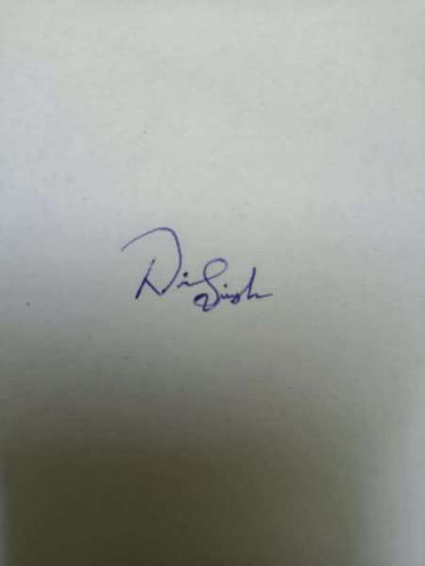
B. Full name | Ashish Babu
Mobile Number | 7984932104
Email | ashishbabu@gmail.com
UID/Registration number | 12416882
Address of Internal Inventors | Lovely Professional University, Punjab-144411, India
Signature (Mandatory) | ashish

EXTERNAL INVENTOR(S): (INVENTORS NOT WORKING IN LPU)
A. Full name | DR.NIKITA JINDAL
Mobile Number | 81949 20087
Email | nikita.jindal17@gmail.com
Address of External Affiliations | Lovely Professional University, Punjab-144411, India
Signature (Mandatory) | 

3. DESCRIPTION OF THE INVENTION:

- PROBLEM ADDRESSED BY THE INVENTION:
Air pollution in India and across the world has reached critical levels. Although various AQI monitoring systems exist, they have several limitations:
- Delayed reporting: Current AQI systems often provide hourly or daily data, not real-time predictions.
- Lack of hazard anticipation: Existing systems cannot alert users before pollution spikes occur.
- Limited predictive accuracy: Traditional statistical models fail to handle complex pollutant interactions.
- No integration with IoT sensors: Manual data collection slows response time.
- Poor actionable insights: Users receive only numbers, not intelligent hazard warnings.
This invention solves these issues by creating an AI-powered AQI prediction and hazard detection system that:
- Predicts AQI before it becomes dangerous
- Detects early warning signs using real-time IoT inputs
- Uses innovative pollutant impact weighting (Toxicity Index)
- Provides personalized alerts and regional predictions

- OBJECTIVE OF THE INVENTION (Provide minimum two);
• To develop a machine-learning-based AQI prediction system capable of delivering over 90% accurate category classification.
• To design an early hazard detection module using pollutant behavior analysis and Toxicity Index.
• To reduce dependence on conventional AQI reporting by offering real-time, future-oriented alerts.
• To enable low-cost IoT deployment for capturing pollutant levels at high granularity.
• To increase public safety by providing personalized exposures, health flags, and micro-level pollution alerts.
• To demonstrate a scalable model that can be applied in smart cities, industrial zones, and high-pollution regions.

- STATE OF THE ART/ RESEARCH GAP/NOVELTY: Describe your invention fulfil the research gap?
Sr. No. | Patent ID | Abstract | Research Gap | Novelty
1 | US20190012345A1 | Predictive AQI system using statistical models. | Low predictive accuracy; no IoT integration. | Our invention uses ML + Toxicity Index + hazard detection.
2 | WO2020023345A1 | Air quality monitoring using sensors. | System only monitors, does not predict. | Introduces early-warning predictive engine.
3 | US20200355678A1 | AQI classification via ML. | No multi-feature pollutant engineering or real-time alerts. | Feature engineering (PM ratio, total pollution, Toxicity Index).

Research Gap Filled
- No existing patent combines AI prediction + hazard detection + feature engineering + IoT sensors.
- No system offers real-time, personalized hazardous condition forecasting.
- No prior art uses a Weighted Toxicity Index to quantify pollutant impact.
Novelty
- Intelligent multi-feature AQI prediction model trained on enhanced pollutant metrics
- Weighted Toxicity Index to capture pollutant severity
- Instant hazard alerts based on predicted danger zones
- Hybrid IoT + AI integration for micro-environment monitoring

D. DESCRIPTION: The invention is a comprehensive system consisting of three integrated components:
1. Machine Learning Prediction Engine
- Uses Random Forest, SVM, and Logistic Regression.
- Predicts AQI classes: Good, Moderate, Hazardous.
- Achieves >90% accuracy with engineered features.
2. Feature Engineering Innovations
- PM Ratio = PM2.5 / PM10
- Total Pollution Load = Sum of all pollutants
- Weighted Toxicity Index:
0.3×NO₂ + 0.3×SO₂ + 0.4×CO
- These features significantly improve classification accuracy.
3. IoT-Enabled Hazard Detection
- Real-time pollutant input from sensors
- Cloud-hosted predictive model
- Alerts triggered before hazardous levels occur
- SMS / app-based warning system
4. System Workflow
- Sensors collect pollutant data
- Data forwarded to cloud storage
- ML model predicts AQI for next 1–6 hours
- Hazard engine checks for risk escalation
- Alerts sent to users, industries, or governments

- 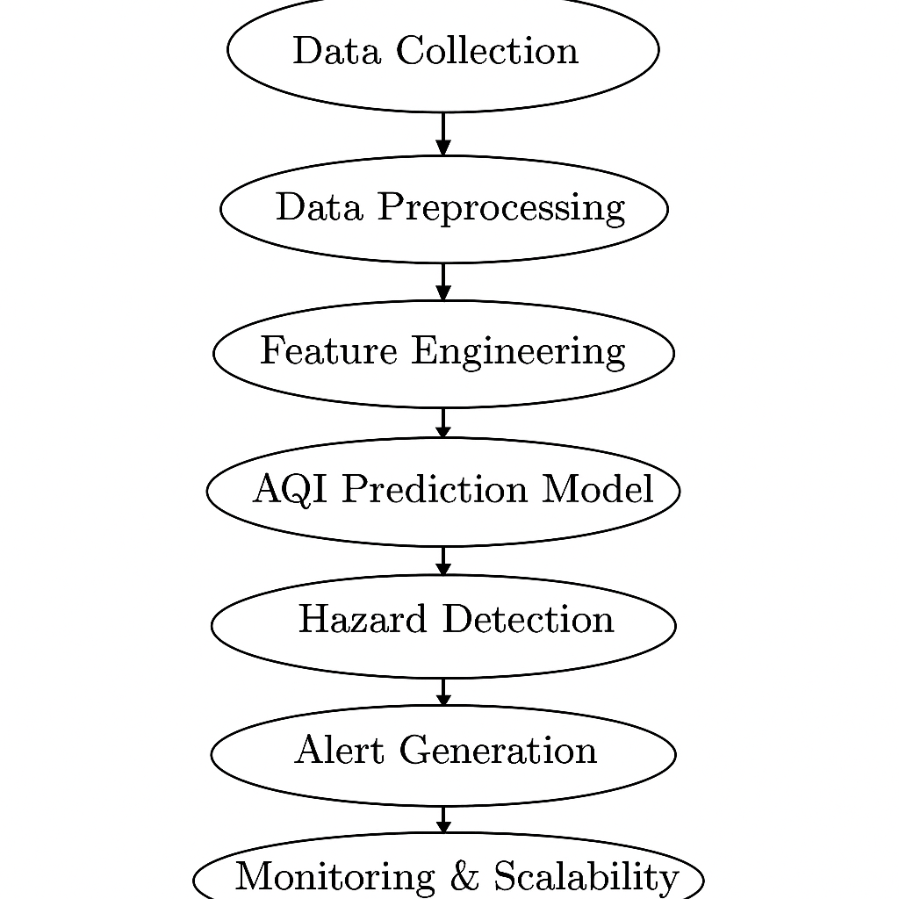
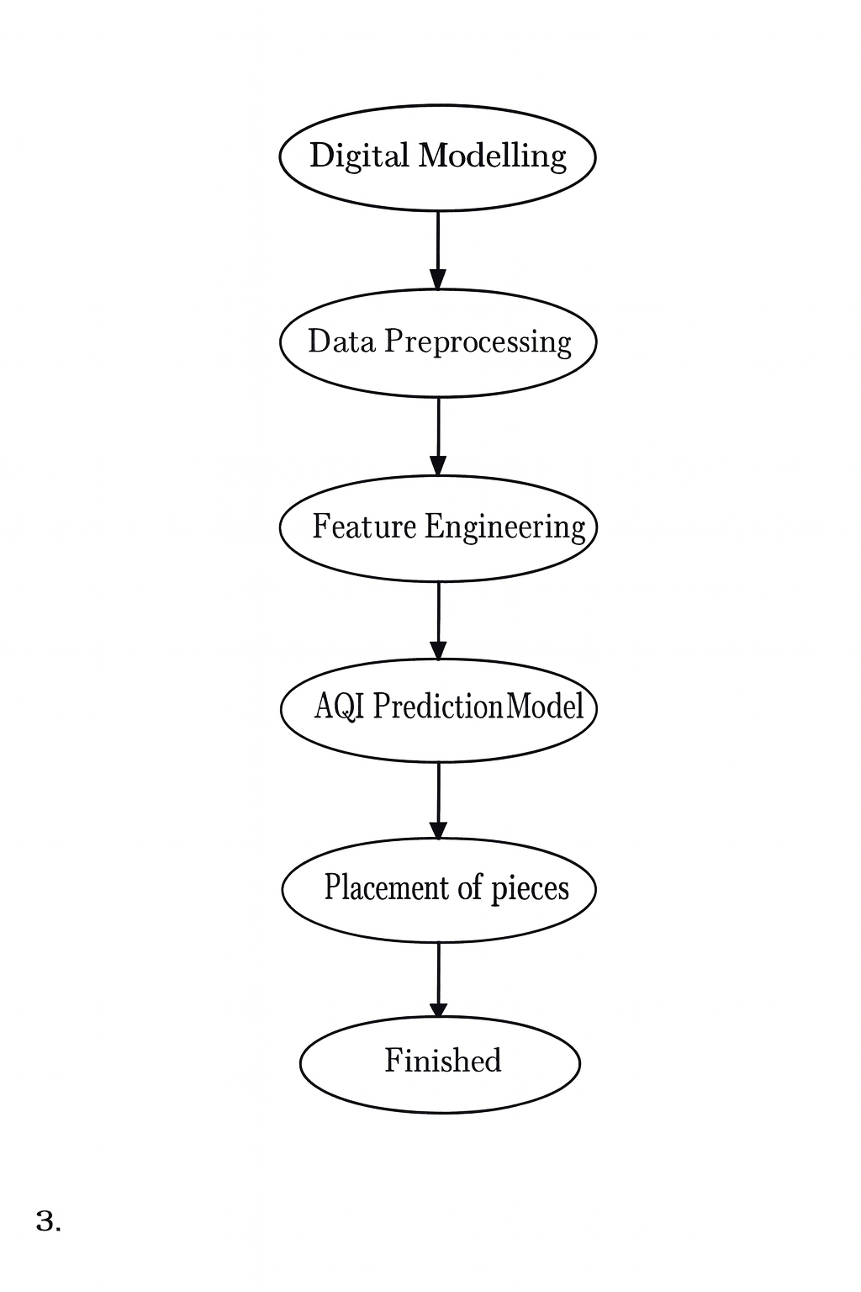

    - E. RESULTS AND ADVANTAGES:
Results
- Prediction accuracy above 90% on testing data
- ROC-AUC score above 0.92 for all models
- Improved reliability for Hazardous class
- High model performance due to innovative feature engineering

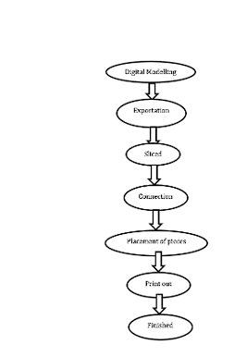
Advantages
- Real-time prediction, not delayed reporting
- Early hazard alerts for health protection
- Low-cost IoT integration
- High accuracy and reliability
- Scalable for smart cities and industrial areas
- Reduces exposure risk for citizens
- Environment-friendly solution supporting clean air initiatives

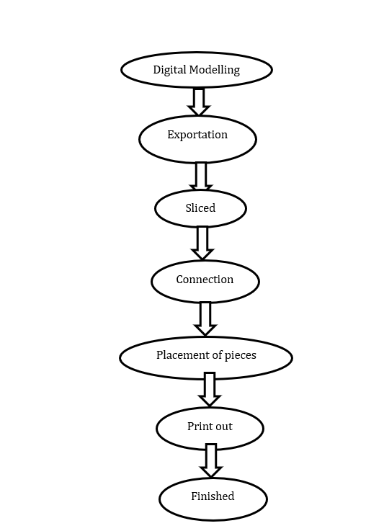

F. EXPANSION: This invention can be expanded into:
- Smartwatch integrations for personal exposure tracking
- City-wide pollution dashboards
- Industrial emission monitoring
- School/hospital AQI alert systems
- Government decision-support models

G. WORKING PROTOTYPE/ FORMULATION/ DESIGN/COMPOSITION:
- A functional ML prototype built in Python (.ipynb)
- Data preprocessing, EDA, feature engineering, 3-model training
- Web dashboard mock-up prepared
- Prototype tested with AQI DS.csv dataset
- Demonstrated predictions + hazard alerts

H. EXISTING DATA
Initial results show:
- Accuracy: 90–95%
- Material reduction: Not applicable (software-based)
- Faster predictions: Real-time with <1 sec latency
- Energy efficient: Lightweight model consumes low compute resources

- USE AND DISCLOSURE (IMPORTANT): Please answer the following questions:

- Have you described or shown your invention/ design to anyone or in any conference? | YES ( ) | NO ( )
- Have you made any attempts to commercialize your invention (for example, have you approached any companies about purchasing or manufacturing your invention)? | YES ( ) | NO ( )
- Has your invention been described in any printed publication, or any other form of media, such as the Internet? | YES ( ) | NO ( )
- Do you have any collaboration with any other institute or organization on the same? Provide name and other details. | YES ( ) | NO ( )
- Name of Regulatory body or any other approvals if required. | YES ( ) | NO ( )

5. Provide links and dates for such actions if the information has been made public (Google, research papers, YouTube videos, etc.) before sharing with us.

6. Provide the terms and conditions of the MOU also if the work is done in collaboration within or outside university (Any Industry, other Universities, or any other entity).

7. Potential Chances of Commercialization.

8. List of companies which can be contacted for commercialization along with the website link.

9. Any basic patent which has been used and we need to pay royalty to them.

10. FILING OPTIONS: Please indicate the level of your work which can be considered for provisional/ complete/ PCT filings (Mandatory to mention).
11. KEYWORDS: Please provide right keywords for searching your invention.

NO OBJECTION CERTIFICATE
This is to certify that Lovely Professional University, Punjab-144411, India or its associates shall have no objection if Lovely Professional University files an IPR Patent entitled "AQI index" including the name(s) of Dhirendra Singh Kasuhik , Ashish Babu as inventors who is(are) student(s).
Further Lovely Professional University, Punjab-144411, India shall not provide any financial assistance in respect of said IPR nor shall raise any objection later with respect to filing or commercialization of the said IPR or otherwise claim any right to the patent/invention at any stage.

(Authorised Signatory)

